

Programacion de motores

Victor Orts Torner



14 de junio de 2017

ESAT

# Engine features

Components

Components that are adding in the cass entity

Types components implemented

Script Component

I use chaiscript because it is very oriented to c++ and also thread safe.

This component manage the entity around the scripts.

What can you do with the script?

Rotation,translate and scale of the entity.

What is the sintax of the script ?

Is Unity like :

Start() and Update();

RenderComponent

This component is used for drawing,they contain the mesh and the material for the correct drawing.

This component makes commands.

Light Component

It depend the ilumination of the scene ,they have tree types:

1. Directionallight
2. Pointlight
3. Spotlight

Not implemented but thinking audio component .why not included ¿ Because the library irrklang using some dll and i wasnt to overload the engine of dll.

Sombras

Sombras

Load and save of scenes with cereal, we créate our own structures for save the data of the entity ,camera ,light .

For this proposal we used cereal (<https://github.com/USCiLab/cereal>)

User interface

We used for the control of the scene management entity , light .cameras and change postprocess.

Also has a option for load and save scene.

We used Nuklear as a GUI for the scene magamente simple but effective aswell some paramteres can be modify by scripting.

The was a option to change the draw mode between wireframe_mode or triangles_mode

But actually is deprecated for changes in the engine.

# Implemented techniques

Sobel operator – Freichen technique

Its a common technique as a first step to differents postprocess.

Like Toon shading

 + 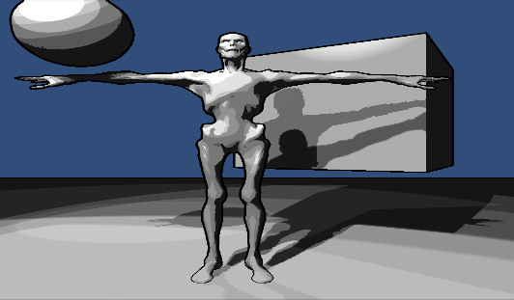

Sobel operator calculer all the positions of the image from topleft to bottom right .

Othre postprocess we implemented it is a gradient tipical for class test,

Consist depends on the value of uv x or y , put it as a value in a color

Like vec4(uv.x,0,0,1.0) ,so the red color will increase until get 1.0f

# 

Simple blur

You can choose the number of pixels will pick from the closest área

For int x = numberpixesl ;x<numberpixels

For int y = numberpixels;y<=numberpixels

Make the sum;



# Strategies and Solutions to development problems

**Problems with task and multithreading**

Mi first aproach to multithreading was a simple system of producer and cosumer of task.That work fine but was incompleted.The next aproach of multithreading was a system of task for the engine.

The main thread visiti the update and generate task for the system.

¿Who creates tasks? Entity -> updateMatrix

    Scene -> display Task -> Un frame

What other tasks could be implemented ¿ I tried a texture taskd also for the OBJ ,but was quite disspaointing the experience.

**Shadow Texture**

I had some issues about the upload of the shadowtexture because i didnt end the part of glactivetexture and i was overloading the shadowtexture with the diffuse texture.

**Ralentización del motor**

Had problems creating my own struct for save the uniforms values , and i swith to std::map because is more faster instead using my own struct in a vector .

Remake of the component system

For make my component system i take a look in this library (<https://github.com/alecthomas/entityx>) ,made i new desing for the components with templates.

The reason i move to templates is to avoid the creation of std:shared_ptr in the main ,and make it cleaner .

Problems with cereal

At the time to save the vec3 and vec4 and glm structures ,i have to make some structs for save it in the file glmtypes.h

Problem with string creation and compararison of strings

When i was uploading uniforms and save the information of this in a

std::map<string,int> Name uniform and postion, at the time of use it with the light appera a problema with the perfomance because i was creating strings and also caomparing strings at the same time , i changed the comparison of strings for ints .

ligth[+to_string(id)+].type ,to void the creation of string in the comparison i replace the string to enum.that makes easiest and faster.

Ej. It.first == uniform::type

# Libraries used in the engine

|  |  |  |
| --- | --- | --- |
| Name | Proposal | Web |
| nuklear | Gui of the engine | https://github.com/vurtun/nuklear |
| Cereal | serialization | https://github.com/USCiLab/cereal |
| chaiscript | Script of the engine | https://github.com/ChaiScript/ChaiScript |
| Glfw | Window management | https://github.com/glfw/glfw |
| Glew | Opengl extensión | http://glew.sourceforge.net/ |
| STB | For different proposals, load images,truetype | https://github.com/nothings/stb |
| Minitrace | For profiling the threads and engine | https://github.com/hrydgard/minitrace |

# Video

https://www.youtube.com/watch?v=zoOYj_k1QlI